**EX:04- Create a simple cloud software application for Car Booking ReservationSystem using any Cloud Service Provider to demonstrate SaaS.**

**Aim**

To Create a simple cloud software application for Car Booking ReservationSystem using any Cloud Service Provider to demonstrate SaaS.

**Procedure**

* **Login to Cloud Platform** – Sign in to a cloud service provider like Zoho Creator / AWS / Google Cloud.
* **Create New Application** – Start a new app project, either from a blank template or using a ready-made one.
* **Design Forms & Modules** – Add forms for customer details, car details, booking requests, and payment info. Create reports to show available cars, booking history, etc.
* **Set Workflows & Logic** – Automate tasks like booking confirmation, availability check, email/SMS alerts, and payment validation.
* **Deploy the Application** – Publish the app on the cloud so it works online.
* **Provide SaaS Access** – Share the application link with users so they can book cars anytime, anywhere through the cloud as a SaaS service.

**Output**

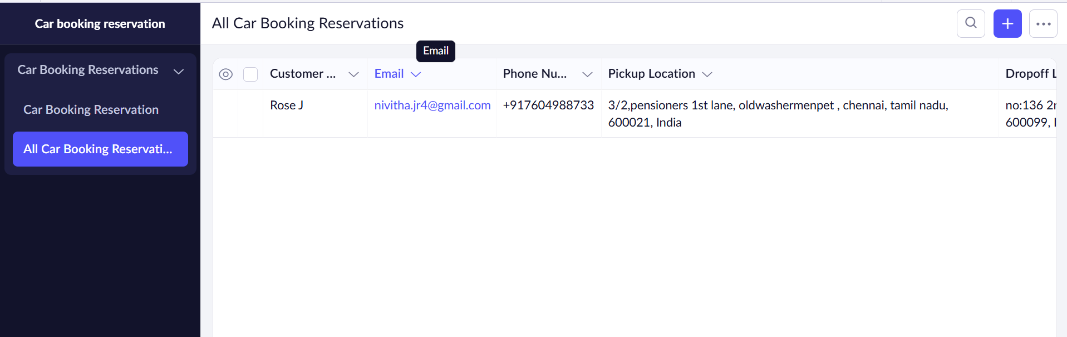

**Result**

Thus, a simple cloud software application for Car Booking ReservationSystem using any Cloud Service Provider to demonstrate SaaS created successfully.